Avalon Community Park  Little, Minor, Instructional & T-Ball Games  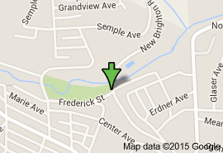  From Interstate 279:  - Take exit number 14 - Bellevue / West View  - Turn LEFT onto Union Ave for 1.4 miles.  - Turn RIGHT at the stop light onto New Brighton Rd. for 0.2 miles.  - The main fields are on the left, just across from the Avalon Fire Hall. Field 2, used for Instructional and T-Ball only, is on the right behind thE Avalon Pool.  From Route 65 - Ohio River Boulevard:  - In Bellevue there is a McDonald's on Route 65. Across from the McDonald's is the "Welcome To Bellevue" sign. Turn here!  - Turn LEFT immediately after this small island onto W Riverview Ave. for 0.4 miles. (W Riverview becomes Starr Ave)  - At the top of the hill you will see Kuhn's on your right. Continue straight through this stop light.  - At the bottom of the hill, at the next stop light, continue straight onto New Brighton Road for 0.2 miles.  - The main fields are on the left, just across from the Avalon Fire Hall. Field 2, used for Instructional and T-Ball only, is on the right behind thE Avalon Pool. | Bellevue Memorial Park  Pony, Colt League Games  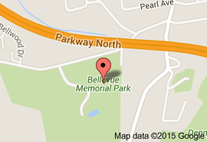  From Interstate 279:  - Take exit number 12 - Perrysville Ave. Get in left lane as you approach the traffic light.  - Turn left at light onto Perrysville Avenue and go about 0.9 miles to second traffic light.  - Turn left onto Bellevue Road for about .6 miles.  - Bear right, following Bellevue Road for about 0.3 miles.  - Turn left into Bellevue Memorial Park. The field is on the left.  From Route 65 - Ohio River Boulevard:  - In Bellevue there is a McDonald's on Route 65. Across from the McDonald's is the "Welcome To Bellevue" sign. Turn here!  - Turn LEFT immediately after this small island onto W Riverview Ave. for 0.4 miles. (W Riverview becomes Starr Ave)  - At the top of the hill you will see Kuhn's on your right. Turn right onto Lincoln Ave.  - Follow Lincoln Ave about 0.25 miles to the next stop light. Turn left onto North Balph Ave. (North Balph becomes Bellevue Road.)  - Follow Balph/BellevueRoad for about 1.2 miles.  - Turn right into Bellevue Memorial Park. The field is on the left.

